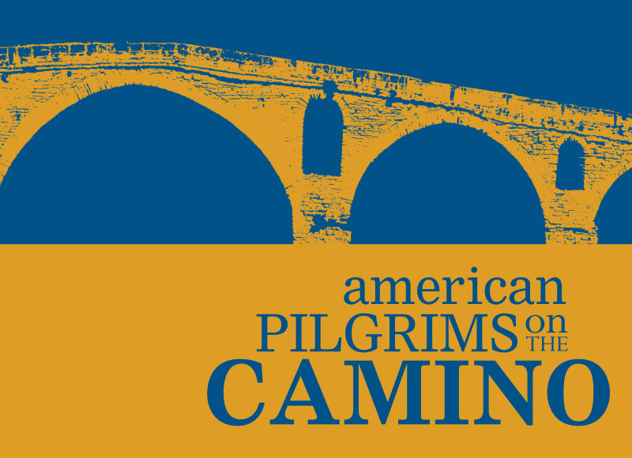
Our Vision: We inspire all who seek the spirit of the Camino to connect with the global community of pilgrims.

Our Mission: We foster the enduring tradition of the Camino by supporting its infrastructure, gathering pilgrims together, and providing information and encouragement to past and future pilgrims

American Pilgrims on the Camino, 2019 Grant Cycle

Purpose
American Pilgrims on the Camino Grant Program works toward fulfilling the organization's vision and mission.

Grant Criteria
Grant applications will be considered to fund projects that develop or improve the infrastructure of the Camino de Santiago. These grants are typically made to albergues or other organizations involved in Camino infrastructure development in Spain, France, and Portugal. Maximum grant is US$6,000. Please use the form within this document to apply.

Proposal Submission
Proposals must be submitted electronically using this form. The deadline for submission is February 1, 2019. All supporting documents must be scanned and submitted electronically together with this application form. Applications must include the completed check list and must typed. Handwritten applications will not be accepted. All questions must be answered. Incomplete applications will not be considered.

Proposal Eligibility and Review
Individuals, for-profit enterprises or organizations fully subsidized by local, regional or federal governments are not eligible to apply. Grants are not made for funding general operations of an organization or albergue. Applicants must provide evidence of legal and official status as a non-profit entity at the time of application.

A review committee, made up of American Pilgrims on the Camino Board members and members at large will review all applications. The American Pilgrims Board will review committee recommendations and approve funding.

A primary review criterion for all applications is the project’s ability to further the American Pilgrims on the Camino mission. Please explain in your proposal how your project is consistent with our vision and mission. Another important review criterion is the applicant’s resourcefulness in seeking funding from other sources. Please explain what additional sources of funding are being used or sought to support your project. This is a competitive process, and grant funds are limited. American Pilgrims on the Camino may be able to award only a portion of the requested amount.

Proposal Funding
Notification of funding will be made no later than May 1, 2019. Successful applicants are required to submit the American Pilgrims on the Camino Grant Acceptance Form, which will be made available at the time of award notification. No funding will be transferred prior to receipt of the Grant Acceptance Form.

Spending and Reporting Policies
American Pilgrims on the Camino funding is to be spent within one calendar year of the award. Grant recipients will be required to submit a final report within six months of the expenditure of the grant funds. The final report requirements will be communicated to grant recipients at the time of award notification.

Questions and Inquiries
If you have questions or would like additional information about the American Pilgrims on the Camino Grant Program, please email them to: Grants@americanpilgrims.org.

American Pilgrims on the Camino is registered with the U.S. Internal Revenue Service as a 501(c)(3) not-for-profit organization.

American Pilgrims on the Camino
Grant Application Cover Sheet

Name of proposed project:

Amount requested (US$):
US$6,000 maximum

Please verify that the proposal includes the following REQUIRED documents:
Two letters of referenced
Project budget
Proof of non-profit status. In the United States, the 501(c)(3) form. In Spain, the cover page of the estatutos.

Organization name:

Telephone number:
(include country code if not in the US)

E-mail address:

Website

Mailing address:

Type of organization (NGO, albergue, etc):

Non-profit or registered charity number

Year organization was established

Organization personnel: How many work and/or volunteer with this organization:
Paid employees
Volunteers

Contact person in the organization for the proposal
Name:
E-mail:
Telephone number:
(include country code if not in the US)

Proposal

All of the sections below must be completed.

Brief description of work performed by organization, including number of pilgrims served directly and indirectly:

Narrative description of entire project.
● What will you do?
● Why is it important?
● What will be its impact on pilgrims and the Camino?
● How many people will benefit from it?

Narrative description of how the funds would be used. We are asking for a description of the entire budget and, if the application is to fund only a portion of the total, a description of the latter part of the total. This description must be consistent with the project's budget that you will include with this application.

Time frame for completion:

Identify who will manage the project, including the individual's background and experience with similar projects:

Other funding sources being sought for the project. Please identify other funding sources and amounts requested:

Has the organization requested funding from American Pilgrims in the past?
If "Yes", date and title of application:

Have you answered all the questions in this application form?

Is the application typewritten?

Please double check your entries! Mistakes result in delays!
Deadline for Acceptance Application is February 1, 2019.

